DECODE(string/column,search1,replace1[,search2,replace2,…][default_value])
default_value is null by default.

Examples:
1. Select sname, rating,decode(rating,10,’High’,7,’Medium’,3,’Low’) as rating_level from
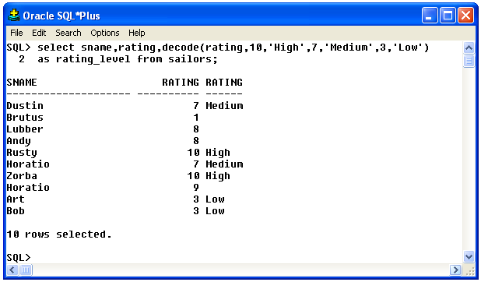
sailors;

2. Select sname, rating, decode(rating,10,’High’,7,’Medium’,3,’Low’,’Others’) “rating_level”
from sailors;
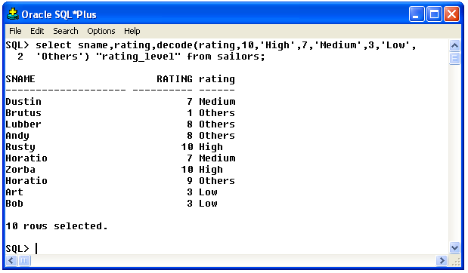

CASE
Examples:
i) Select rating, case rating when 10 then ‘High’
when 7 then ‘Medium’
when 3 then ‘low’
else ‘others’
end
from sailors;
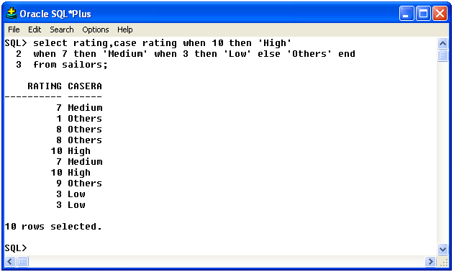

ii) Select rating, case when rating >=7 then 'High'
when rating <7 then 'low'
else 'others'
end
from sailors;
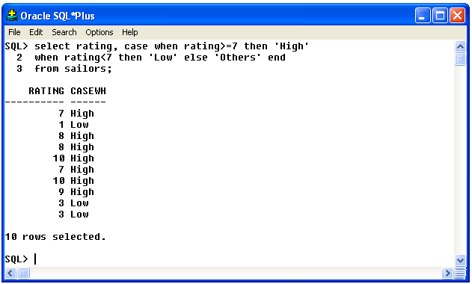

Week 4 practice exercise solutions

1. Retrieve even rows from sailors table
Query: select S.* from sailors S
where S.sid in (select decode(mod(rownum,2),0,sid) from sailors);
2. Write a query to retrieve Nth row where N is entered at runtime.
Query : select * from sailors where sid in (Select decode(rownum,&no,sid) From sailors);
3. Find details of the reservations made by sailor 22 in the month of AUG and OCT.
Query : select * from reserves where substr(trim(day),4,3) in ('AUG','OCT') and sid=22;
4. Find sailors details (do not use wildcards)
a. Whose name contains ‘S’ as a 3rd character.
Query : select * from sailors where substr(upper(trim(sname)),3,1)=’S’;
b. Whose name contains 'E' as a 2nd character from end of the string.
Query : select * from sailors where substr(upper(trim(sname)),-2,1)='E';
or
select * from sailors where substr(trim(sname),-2,1)='e'
c. Whose name contains the letter ‘A’.
Query : select * from sailors where instr(upper(trim(sname)),’A’)!=0;
d. Whose name contains the letter ‘O’ only once.
Query : select * from sailors where instr(upper(trim(sname)),’O’)!=0 and
instr(upper(trim(sname)),’O’,1,2)=0;
5. Write a query to display today's date in dd-month yyyy hh:mi:ss format
Query : select to_char(sysdate,’dd-fmmonth-yyyy hh:mi:ss’) from dual;
6. Write a query to display today's date in the given format: Monday 3rd August 2015
Query : select to_char(sysdate,’fmDay ddth Month yyyy’) from dual;
7. Write a query to display reservation sorted by month
Query : select sid, bid, day from reserves order by to_char(day,’mm’);
8.Write a query to display : Today the date is: 03.08.2015
Query : select to_char(sysdate,’ “Today the date is “ dd.mm.yyyy’) from dual;

Result: performing of simple conditional queries using BUILT-IN functions has been successfully executed.

